**Idea #1 – Lottery Numbers Analyzer**

**NY Take 5 – Pick 5 numbers from 1-39 (575,757)**

App definition statement

* A “smart” lottery number picking tool for those interested in probability of random numbers

Feature brainstorm

1. Randomly pick lottery numbers
2. **Pick lottery numbers most likely to win (based on various factors)**
3. Calculate how likely a pick is to occur and why
4. **Illustrate why some numbers are more likely to win**
5. Choose between common lottery games
6. **Teach probability, statistics, and randomness**
7. Keep track of numbers played and win/loss rates
8. Visualize certain attributes of randomness

Target audience

* Likes to play common lottery games or other games of chance
* Is interested in probability and behavior of random numbers
* Enjoys puzzles and brain games during their spare time

Selected features

1. Teach probability and statistics (NY Take5 for this example)
2. Pick lottery numbers most likely to win
3. Illustrate why some numbers are more likely to win

App sketch

Track spent vs won

Avoiding commonly played numbers

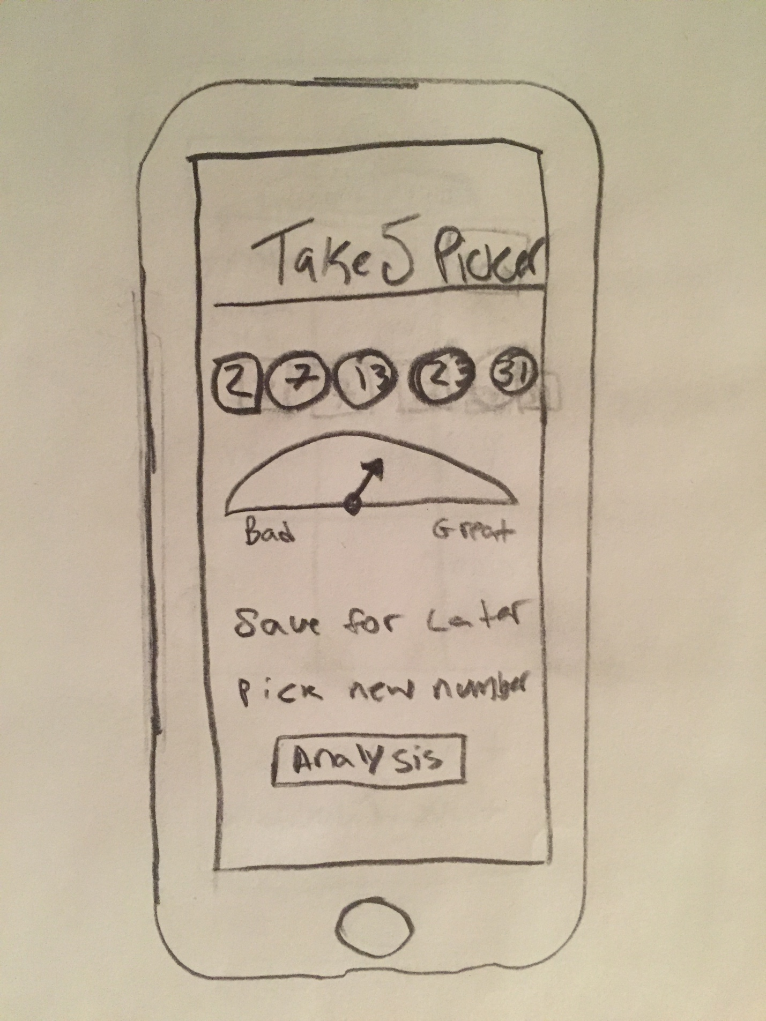

**Idea #2 – Syllabi Manager**

Feature brainstorm

1. **Inputting assignment details and due dates manually**
2. Input via taking an image or uploading document, scanning for assignments
3. **Keep track of assignment due dates and submission dates**
4. Tracking how many days are left before an assignment is due
5. Estimate how many days an assignment should take
6. Saving all original syllabus documents (offline and online)
7. Prioritizing which assignments to work on first
8. Calculating grades based on grading rubric
9. **Remind when an assignment is about to be due**

Target audience

* Needs a quick reference or detailed guide of multiple due dates
* Needs to document which assignments were submitted and when
* Are university students

Selected features

1. Inputting assignment details and due dates manually
2. Keep track of assignment due dates and submission dates
3. Remind when an assignment is about to be due

App definition state

* A syllabus consolidation tool for university students who need to manage their coursework

App sketch

Google calendar sync

Local calendar sync, remove after semseter

Auto input data

Data entry is competition

Link to course code

